Chapter 16, Problem 57.

- Find the Laplace transform of the voltage shown in Fig. 16.80.a.
- Using that value of v_{s}(t) in the circuit shown in Fig. 16.80.b, find the value of v_{o}(t).

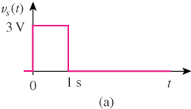

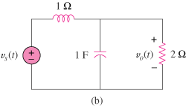

Figure 16.80
For Prob. 16.57.

